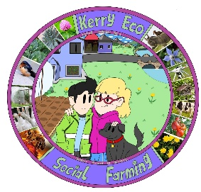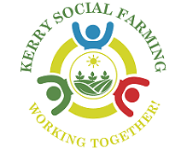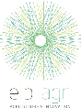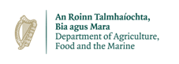
Author(s): Luke Myers
Kerry Eco-Social Farming – an EIP integrated within a Voluntary Model of Social Farming, addressing biodiversity, inclusion and accessibility on farms in Kerry.
Tree veteranisation within linear features of farming enterprises
Overview – The Kerry Eco-Social Farming European Innovation Partnership (KESF EIP) was a nature-based project, funded by the Department of Agriculture, Food and the Marine through the European Innovation Partnership fund. The project was integrated into a voluntary model of social farming, Kerry Social Farming, a community-based project which links up ‘at risk’ groups to local farmers. The project caters to people with additional needs, acquired brain injuries, utilising specific mental health services, the elderly and young people and links up with local volunteer farmers across the county in order to provide inclusion and accessibility on farms. The KESF EIP was a single year Call5 EIP which focused on enhancing the social farming experience for host farmers and participants through the provision of funding, training and guidance on biodiversity and nature-based action.
Background – KESF EIP is built on inclusivity, integration and accessibility, with the project’s main finding being that more science and nature-based schemes must be developed for disadvantaged and ‘at risk’ groups across the country, particularly in rural areas. During this project, a number of actions were undertaken by host farmers and social farming participants across twenty-six farms over the length and breadth of Kerry. The actions prescribed to host farms were relatively simplistic in nature, along with having a positive impact on local biodiversity, for tangible scope in terms of public relations and also to adequately engage and ‘marry-into’ the weekly social farming activities. On one host farm, tree veteranisation was used in order to provide micro-habitats for fungi and beetles, along with roosting areas for bats within a linear treeline dividing grazing fields.
Tree veteranisation is the process by which, through specific techniques, trees are ‘veteranised’ in order to exhibit the features of older trees. Older, veteran, trees hold features as a result of their age, storms, lightning strikes, animal and insect damage and death of limbs. Features of veteran trees include; trunk cracks, dead standing wood, hollowed trunk cavities, fallen deadwood, herbivore bark browsing and bird damage, etc. By exhibiting these features on younger, non-veteran trees, the potential for more roosting, nesting, feeding and living areas for wildlife can be increased on the farm.
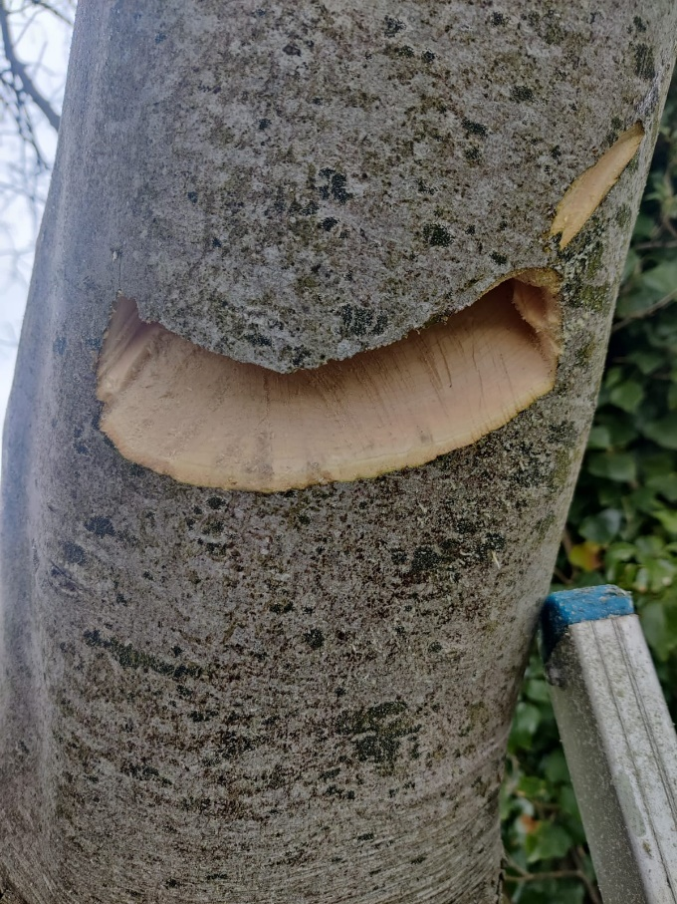
Goals – The aim of KESF EIP was to encourage host farmers and social farming participants to increase the area managed for nature on their farms, through habitat creation, management and improvement. The project’s key performance indicators (KPIs) were specifically developed to maximise the benefits to nature, along with having the abilities of the host farmers and participants in mind. The goal of this aspect of the project was to trial the techniques of tree veteranisation within linear treelines across a host farm. Typically tree veteranisation only occurs in woodland areas, where their aim is to provide a diversity of structure across the entire habitat. Due to the lack of old-age and veteran native trees with suitable features on Irish farms, most farms do not hold enough suitable features for roosting bats and fungi. Bats and fungi are two main contributors to farm productivity, bats predate disease causing insects and fungi contribute to surrounding soil health, therefore they must me retained and enhanced.
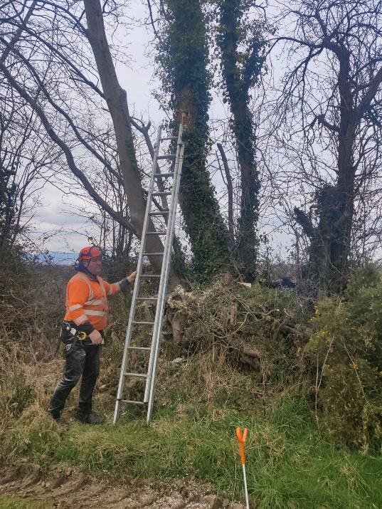
Approach – Four techniques of tree veteranisation were trialed on a host farm in Mid-Kerry in Spring 2023. These techniques were completed by another host farmer, from a different farm, with the help of social farming participants. Bat slots are vertical incisions into the tree using a chainsaw in order to provide a nice thick cavity for bats to roost. Fungi scrapes mimic herbivore browsing and include the scraping and damaging of a specific face of a tree trunk in order to enhance the growth of fungi in the area. Standing deadwood involves the ring barking of tree branches in order to kill the branch and allow for an area of standing dead wood within the tree, suitable for insects. Wood piles are often seen at the base of olde veteran trees, they cand be made by pilling wood at the base of a tree and allowing it to rot down over a number of years.
All host farmers associated with Kerry Social Farming have specific funding allocated to them in order to provide farm upgrades and health and safety equipment, such as first aid kits, in order to allow the farm to become a safe place for social farming participants to get involved. In addition to this, participating social farming participants and support staff wore high visibility jackets and appropriate foot ware when observing and completing the methods discussed. During chainsaw work, all participants and support staff stayed the field’s width or length (whatever was greater) away from the works being completed. These works were then inspected by the group once the area was deemed safe.
Results –
See the table below for the features developed on the veteranisation trial host farm in February 2023.
Tree No. | Species | Age | Features developed
1 | Ash/ Fuinseog (Fraxinus excelsior) | 30 | Ring bark of upper branches
2 | Ash/ Fuinseog (Fraxinus excelsior) | 35 | Bat roost incision
3 | Ash/ Fuinseog (Fraxinus excelsior) | 40 | Small bird box incision
4 | Ash/ Fuinseog (Fraxinus excelsior) | 70 | Fungi herbivore scrape
5 | Ash/ Fuinseog (Fraxinus excelsior) | 60 | Fungi herbivore scrape
6 | Ash/ Fuinseog (Fraxinus excelsior) | 45 | Fungi herbivore scrape
7 | Ash/ Fuinseog (Fraxinus excelsior) | 50 | Fungi herbivore scrape
8 | Ash/ Fuinseog (Fraxinus excelsior) | 40 | Fungi herbivore scrape
9 | Ash/ Fuinseog (Fraxinus excelsior) | 30 | Fungi herbivore scrape
10 | Ash/ Fuinseog (Fraxinus excelsior) | 55 | Fungi herbivore scrape

Learnings – ‘At risk’ groups can assist with aspects of many, if not all, nature-based actions on Irish farms. Actions need to be properly managed and assessed to identify these openings where everyone can have the chance to become involved and assist.
Resources –
Beck, R. (2014). ‘Wood Wise – Woodland Conservation News Spring 2014’. Woodland Trust. Accessed online Available at: https://www.woodlandtrust.org.uk/media/1798/wood-wise-ancient-trees.pdf. Date Accessed: 20th February 2023.
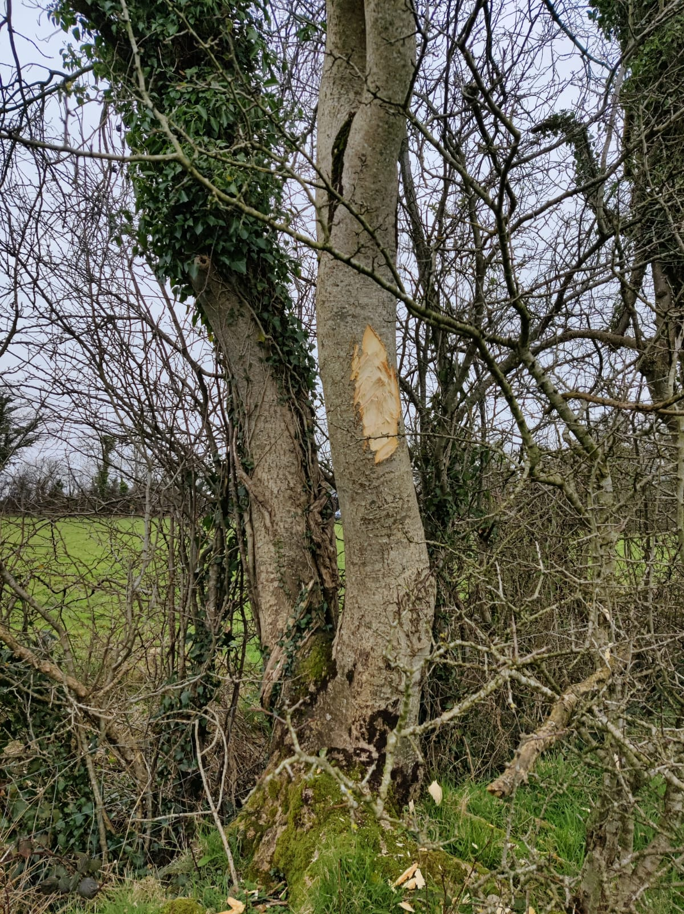
‌
This project was funded by the Department of Agriculture, Food and the Marine under the European Innovation Partnership Fund.
